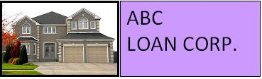

We offer 30-year fixed rate Jumbo loans.

30-Year Fixed-Rate Jumbo
This type of loan offers lower monthly payments as compared to a shorter loan timeframe. This loan type is a good choice if you want stable payments over the life of the loan and plan to live in your home for many years.
Jumbo loans have higher fees and rates due to the risk involved in loaning money. If, after a 10-year period, there are no late payments, the loan terms will be reduced by 1.5%.
Based on your down payment, credit rating, and processing fee options, the interest rate for 30 years is:

 | 2.5% Fee | 1.5% Fee | 0.5% Fee
Conventional | 6.75% | 6.95% | 7.15%
Non-conventional | 7.75% | 8.0% | 8.25%

Interest rates are subject to change. Please contact our loan officer for the latest rates.

1-800-ABC-LOAN

info@mymail.com

